GATE QUALIFIER
Computer Engineering Department
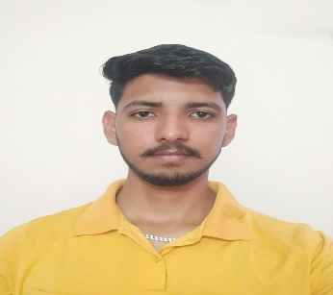  Shivam Kumar  2022-2026 | 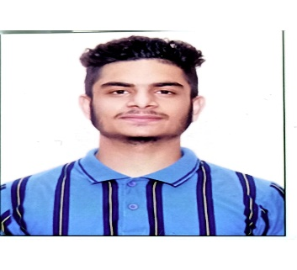  Ajay Kumar  2022-2026 |   Ritik  2022-2026
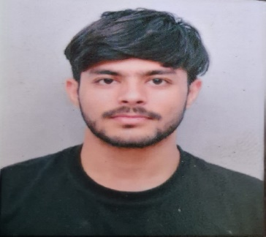  Ankit Kumar Tiwari  2022-2026 | 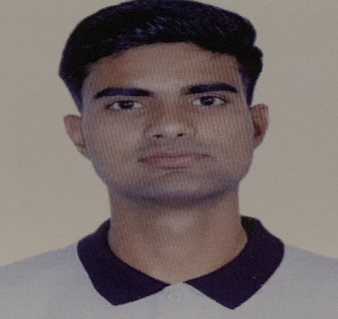  Keshav Rana  2022-2026

