Lesson Plan
Subject : Essence of Indian Traditional Knowledge
Lesson plan Duration : 15 Weeks
Work load (lecture/Practical) per week (in hours): Lectures:3 hours
Lecture No | Theory
1 | Basic structure of Indian Knowledge system
2 | Basic structure of Indian Knowledge system
3 | Basic structure of Indian Knowledge system
4 | 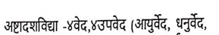
5
6
7
8
9
10
11
12
13
14
15
16
17
18
19
20 | 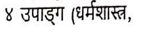
21
22
23
24
25
26
27
28
29 | 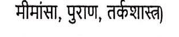
30
31
32
33 | Modern science and Indian knowledge system
34 | Yoga and Holistic Health care
35 | Yoga and Holistic Health care
36 | Yoga and Holistic Health care
37 | Case studies
38 | Case studies
39 | Case studies
40 | Case studies
41 | Case studies

