State Institute of Engineering & Technology
Nilokheri

Computer Engineering Department

Lab manual

Database Management Systems Lab

Code - PC-CS-309LA

INDEX

S. No. | TITLE OF PRACTICAL | DATE | SIGN.
1 | Write the queries for Data Definition Language (DDL) in  RDBMS.
2 | Write the queries for Data Manipulation Language (DML) in RDBMS.
3. | Write SQL queries using logical operators
4. | Create a database and perform the following operations:-
5. | Write SQL queries using Character, Number, Date.
6. | Write SQL queries for relational algebra.
7. | Write SQL queries for extracting data from more than one table.
8. | Write SQL statements for nested sub queries
9. | Perform the concept of views in the table.
10. | To perform various integrity constraints on relational database.

Practical No. 1
Problem Statement: Write the queries for Data Definition Language (DDL) in RDBMS.
Command: CREATE Syntax-
create table <table name>(column1 datatype(precision),column2 datatype(length),...)

Example-
Create table Student(S_Id number(5) primary key, S_Name char(20), Gender char(1), Age number(2))

Output-
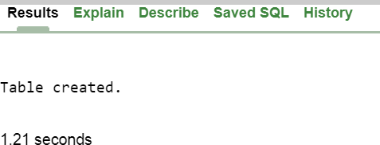

Command: ALTER Syntax-
alter table <table-name> add(column-name datatype(length) )

Example-
Alter table Student add(Father_Name char(20))

Output-
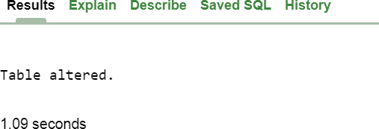

Command: RENAME Syntax-
Rename <oldtable> to <new table>

Example-
Rename Student to Students

Output-
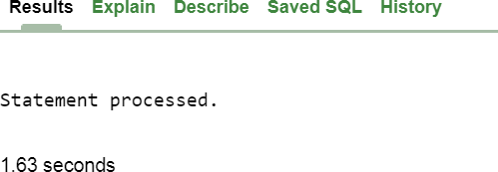

Command: DROP Syntax-
Drop table <table-name>

Example-
Drop table Students

Output-
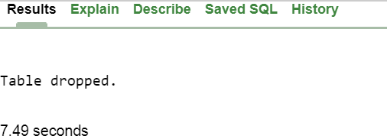

Command: TRUNCATE Syntax-
Truncate table <tablename>

Example-
Truncate table Student

Output-
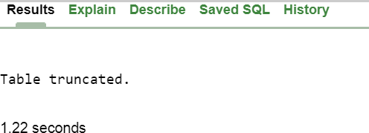

Practical No. 2
Problem Statement: Write the queries for Data Manipulation Language (DML) in RDBMS.

Command: INSERT Syntax-
insert into <table name> values (<expression1>,<expression2>)

Example-
Insert into Student values(‘1000’,’Rinku’,’M’,’20’)

Output-
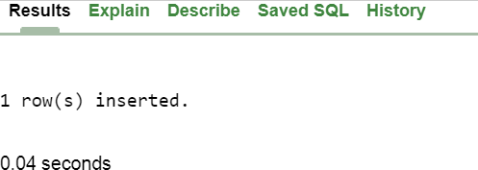

Command: SELECT Syntax-
Select * from <tablename>

Example-
Select * from Student

Output-
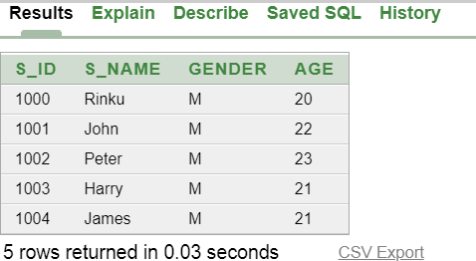

Command: UPDATE Syntax-
update tablename set field=values where condition

Example-
Update Student set Age = 30 where S_Id = 1000

Output-
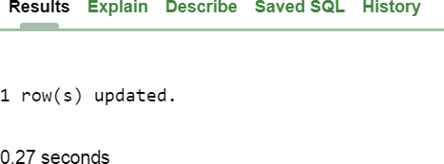

After updating-
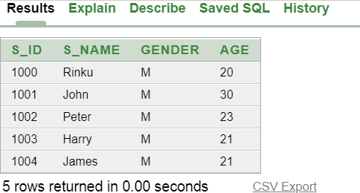

Command: DELETE

Syntax-
Delete from <table-name>

Example-
Delete from Student

Output-

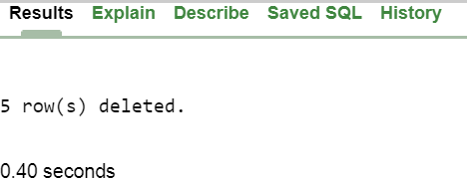

After Deletion-


Practical No. 3

Problem Statement: Write SQL queries using logical operators

Select * from Company1

Output-
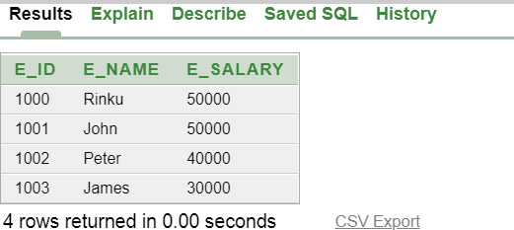

Command- AND

select E_Name from Company1 where E_Id = 1000 and E_Salary = 20000

Output-
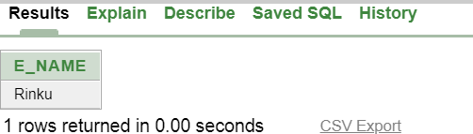

Command - OR

select E_Name from Company1 where E_Id = 1000 or E_Salary = 30000

Output-

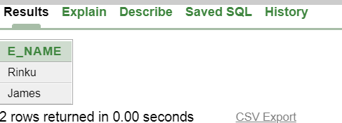

Command – NOT

select E_Name from Company1 where NOT E_Id = 1001

Output-
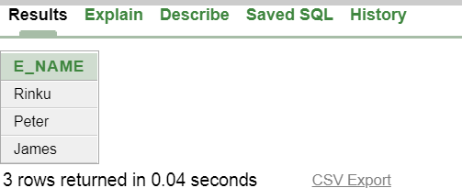

Command - BETWEEN

select E_Name from Company1 where E_Id BETWEEN 1000 and 1003

Output-
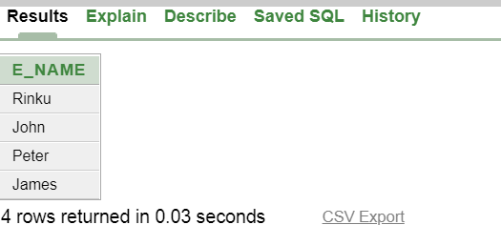
Command- IN

select E_Name from Company1 where E_Id In (1000, 1003)

Output-
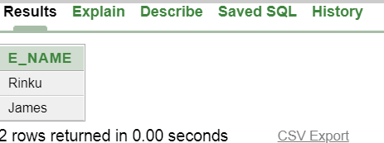

Practical No. 4

Problem Statement: Create a database and perform the following operations:-

Select * from EMP

Output-
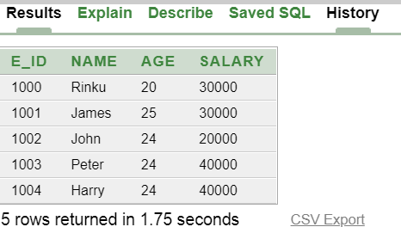

Arithmetic Operations-

Add Operator (+)

Example-
create table EMP(E_ID number(5) primary key, Name char(25), Age number(2), Salary number(5))
insert into EMP values('1000', 'Rinku', '20', '30000') update EMP set Salary = Salary + 1000
select * from EMP

Output-
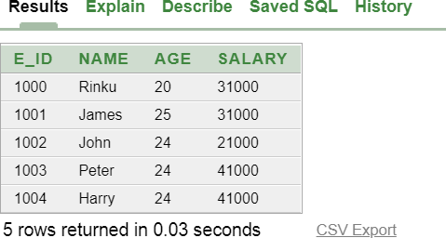

Subtract Operator (-)

Example-

update EMP set Salary = Salary - 1000 select * from EMP

Output-
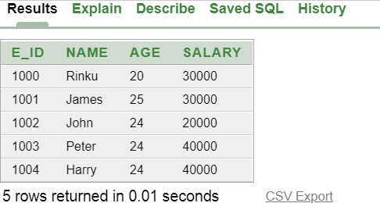

Multiply Operator (*)

Example-

update EMP set Salary = Salary * 1 select * from EMP

Output-
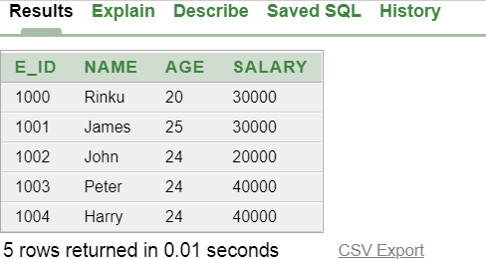

Divide Operator (/)

Example-

update EMP set Salary = Salary / 1 select * from EMP

Output-
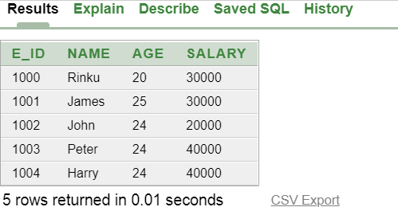

Relational Operations-

Equal Operator (=)

Example-
select * from EMP where Salary = 40000

Output-

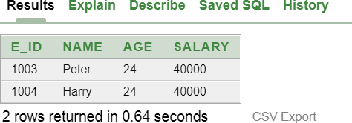

Less than Operator (<)

Example-
select * from EMP where Salary < 40000

Output-

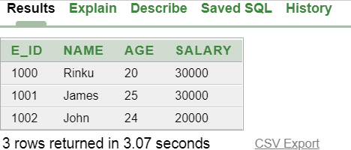

Greater than Operator (>)

Example-
select * from EMP where Salary > 10000

Output-

Greater than or equal to (>=)

Example-
select * from EMP where Salary >= 10000

Output-

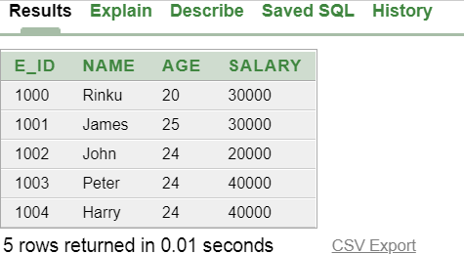

Less than or equal to (<=)

Example-
select * from EMP where Salary <= 50000

Output-
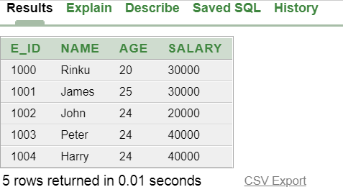

Not equal to (<>)

Example-
select * from EMP where Salary <> 20000

Output-
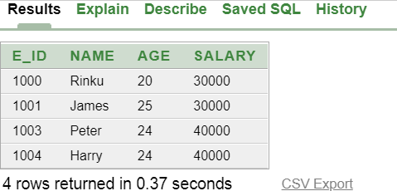

Group By Clause-

Example-
select count(E_ID), Salary from EMP Group by Salary

Output-
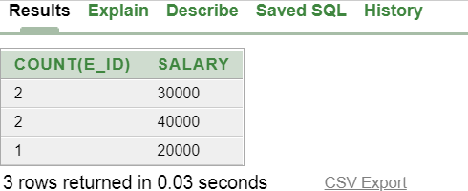

Having Clause-

Example-

select count(E_ID), Salary from EMP Group by Salary having count(E_ID) >= 2

Output-
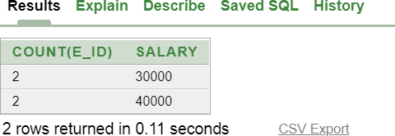

Like predicate for pattern matching in database-

Example-

select E_ID, Name, Salary from EMP where Name like 'R%'

Output-
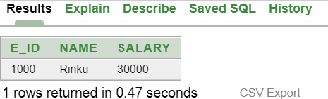

Practical No. 5

Problem Statement: Write SQL queries using Character, Number, Date.

Select * from Company1

Output-

Command- AVERAGE(AVG)

Select Avg(E_Salary) as Avg_Salary from Company1

Output-

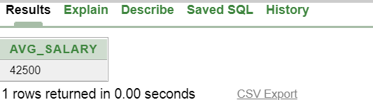

Command : COUNT

select Count(E_Name) as Count_Name from Company1

Output :

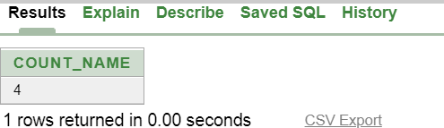

Command - MIN

select Min(E_Salary) as Min_Salary from Company1

Output-
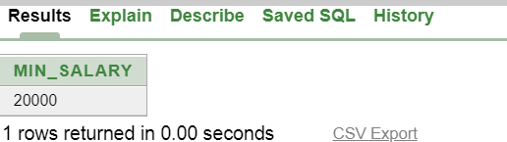

Command - MAX

select Max(E_Salary) as Max_Salary from Company1

Output-
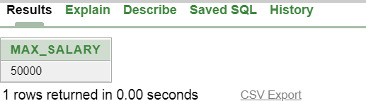

Practical No. 6

Problem Statement: Write SQL queries for relational algebra.

Select * from Company1

Output-
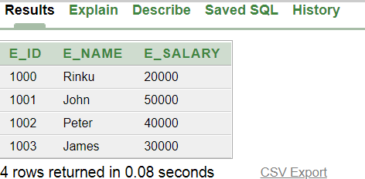

Select * from Company2

Output-
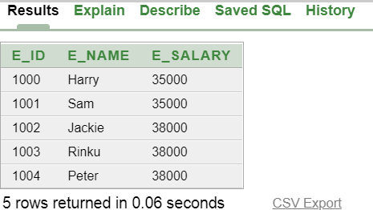

Command- UNION

Syntax-
SELECT column_name(s) FROM table1 UNION SELECT column_name(s) FROM table2

Example-
select E_Name from Company1 union select E_Name from Company2 order by E_Name desc

Output-
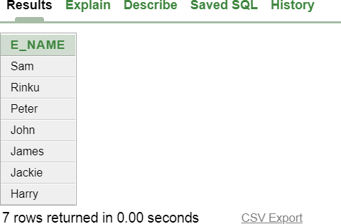

Command- INTERSECT

Syntax-
SELECT column_name(s) FROM table1 INTERSECT SELECT column_name(s) FROM table2

Example-
select E_Name from Company1 intersect select E_Name from Company2 order by E_Name desc

Output-
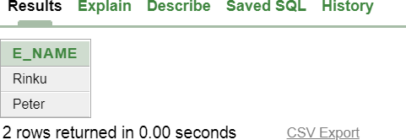

Command- MINUS

Syntax-

SELECT column_name(s) FROM table1 MINUS SELECT column_name(s) FROM table2

Example-
select E_Name from Company1 minus select E_Name from Company2 order by E_Name desc

Output-
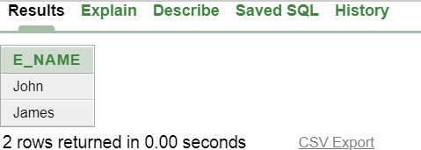

Practical No. 7

Problem Statement: Write SQL queries for extracting data from more than one table.

select * from Employee1

Output-

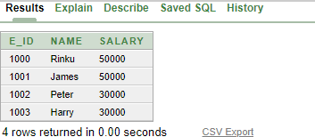

select * from Student1

Output-

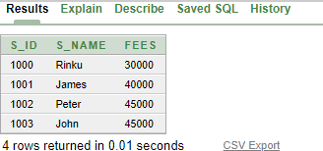

Command- RIGHT JOIN

select Employee1.E_ID, Employee1.Name, Employee1.Salary, Student1.S_ID, Student1.S_Name, Student1.Fees from Employee1 Right Join Student1 on Employee1.Name
= Student1.S_Name

Output-
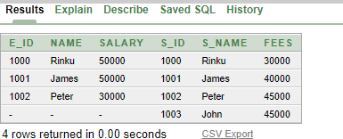

Command- LEFT JOIN

select Employee1.E_ID, Employee1.Name, Employee1.Salary, Student1.S_ID, Student1.S_Name, Student1.Fees from Employee1 Left Join Student1 on Employee1.Name = Student1.S_Name

Output-
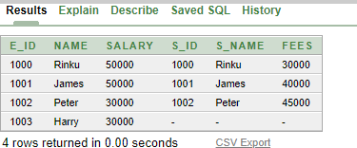

Command- FULL JOIN

select Employee1.E_ID, Employee1.Name, Employee1.Salary, Student1.S_ID, Student1.S_Name, Student1.Fees from Employee1 Full Join Student1 on Employee1.Name = Student1.S_Name

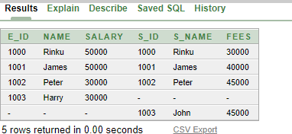

Command- INNER JOIN

select Employee1.E_ID, Employee1.Name, Employee1.Salary, Student1.S_ID, Student1.S_Name, Student1.Fees from Employee1 Inner Join Student1 on Employee1.Name = Student1.S_Name

Output-
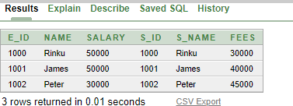

Problem Statement: Write SQL statements for nested sub queries

Select * from Student Output-
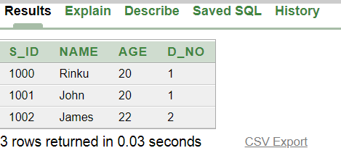

Command –

select Name from Student where Age < (select MAX(Age) from Student)

Output-
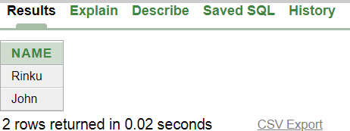

Problem Statement: Perform the concept of views in the table

select * from Test1
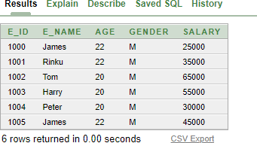

Command- create view V1234 as(select * from Test1 where Salary > 50000)
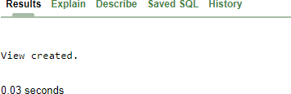

Select * from V1234

Output-
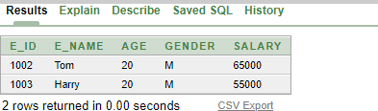

Practical No. 10

Problem Statement: To perform various integrity constraints on relational database.

create table Students(S_Id number(5) primary key, Name char(25), Age number(3)) insert into Students values('1002','James','23')
Select * from Students Output-
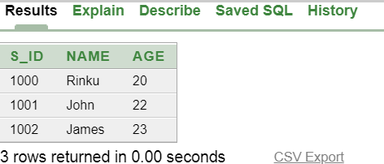

Domain Constraints-

Domain constraints can be defined as the definition of a valid set of values for an attribute. The data type of domain includes string, character, integer, time, date, currency, etc. The value of the attribute must be available in the corresponding domain.

Example-

Insert into Students values(‘1003’,’Rinku’,’One’)

Output-
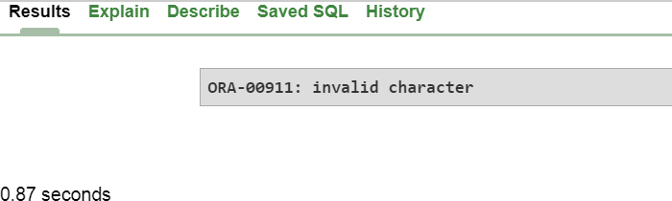

The error occurs because we try to insert a value which is not in correct format.

Entity integrity constraints-

The entity integrity constraint states that primary key value can't be null. This is because the primary key value is used to identify individual rows in relation and if the primary key has a null value, then we can't identify those rows. A table can contain a null value other than the primary key field.

Example-

Insert into Student values(‘ ’, ’Sam’,’20’)

Output-
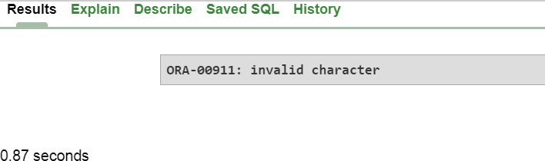

The error occurs because we try to insert null value in primary key attribute which is not possible.

Referential Integrity Constraints-

A referential integrity constraint is specified between two tables. In the Referential integrity constraints, if a foreign key in Table 1 refers to the Primary Key of Table 2, then every value of the Foreign Key in Table 1 must be null or be available in Table 2.

Example-

Table 1-

Create table Dept(D_No number(2) primary key, D_Name char(25))

Insert into Dept values(‘1’, ‘CSE’)…. Select * form Dept
Output-
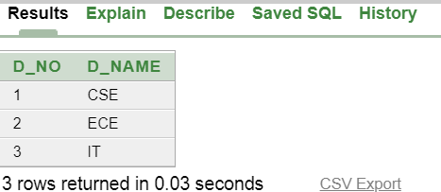

Table 2-

Create table Student(S_Id number(5) primary key, Name char(20), Age number(2), D_No number(2) references Dept(D_No))

Insert into Student values(‘1000’,’Rinku’,’M’,’20’,’1’)….. Output-

Insert into Student values(‘1003’,’James’,’M’,’25’,’5’)

Output-
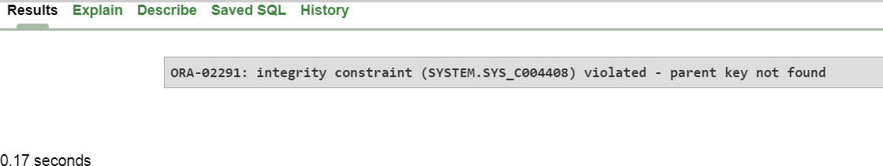

The error occurs because we try to insert D_No-5 in table 2 but the value Is not present in table 1 and violate Foreign Key Constraint.

Key constraints-

Keys are the entity set that is used to identify an entity within its entity set uniquely. An entity set can have multiple keys, but out of which one key will be the primary key. A primary key can contain a unique and null value in the relational table.

Example-

Insert into Student values(‘1000’,’Rinku’,’20’)

Output-
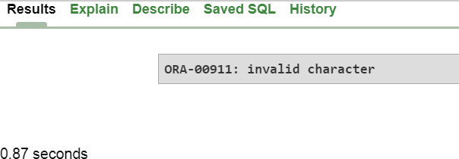

The error occurs because we try to insert duplicate values in our table which violate the Primary key rules.

